TITLE: ML LAB – 08: Clustering (K-Means & Hierarchical)
Student Name: Mahir Desai
Roll No: 23FE10CSE00345
------------------------------------------------
AIM
Build K-Means and Hierarchical classification models using the IRIS dataset and evaluate their performance using appropriate metrics.
------------------------------------------------
Experiment 1: K-Means Clustering
Dataset: IRIS Dataset from UCI Machine Learning Repository
a) Load the dataset and split it into training and testing sets
import numpy as np
import pandas as pd
import matplotlib.pyplot as plt
import seaborn as sns
from sklearn.preprocessing import StandardScaler
from sklearn.cluster import KMeans, AgglomerativeClustering
from sklearn.metrics import silhouette_score
from scipy.cluster.hierarchy import dendrogram, linkage
# Load dataset
columns = ["sepal_length", "sepal_width", "petal_length", "petal_width", "species"]
data = pd.read_csv("iris/iris.data", header=None, names=columns)
df = data.drop("species", axis=1)
# Feature Scaling
scaler = StandardScaler()
X_scaled = scaler.fit_transform(df)
First five rows of dataset:
sepal_length sepal_width petal_length petal_width
0 5.1 3.5 1.4 0.2
1 4.9 3.0 1.4 0.2
2 4.7 3.2 1.3 0.2
3 4.6 3.1 1.5 0.2
4 5.0 3.6 1.4 0.2
Training Data Shape (Scaled): (150, 4)
b) Train a K-Means Clustering model (k=3).
# Initialize and train K-Means
kmeans = KMeans(n_clusters=3, random_state=42)
kmeans_labels = kmeans.fit_predict(X_scaled)
c) Evaluate the model using Silhouette Score.
# Evaluate K-Means
kmeans_silhouette = silhouette_score(X_scaled, kmeans_labels)
print(f"K-Means Silhouette Score: {kmeans_silhouette:.4f}")
K-Means Silhouette Score: 0.4451
Experiment 2: Hierarchical Clustering (Agglomerative)
a) Train a Hierarchical Clustering model.
# Initialize and train Agglomerative clustering
hierarchical = AgglomerativeClustering(n_clusters=3)
hierarchical_labels = hierarchical.fit_predict(X_scaled)
b) Evaluate the model using Silhouette Score.
# Evaluate Hierarchical clustering
hierarchical_silhouette = silhouette_score(X_scaled, hierarchical_labels)
print(f"Hierarchical Clustering Silhouette Score: {hierarchical_silhouette:.4f}")
Hierarchical Clustering Silhouette Score: 0.4411
c) Visualize the cluster distribution using a Dendrogram.
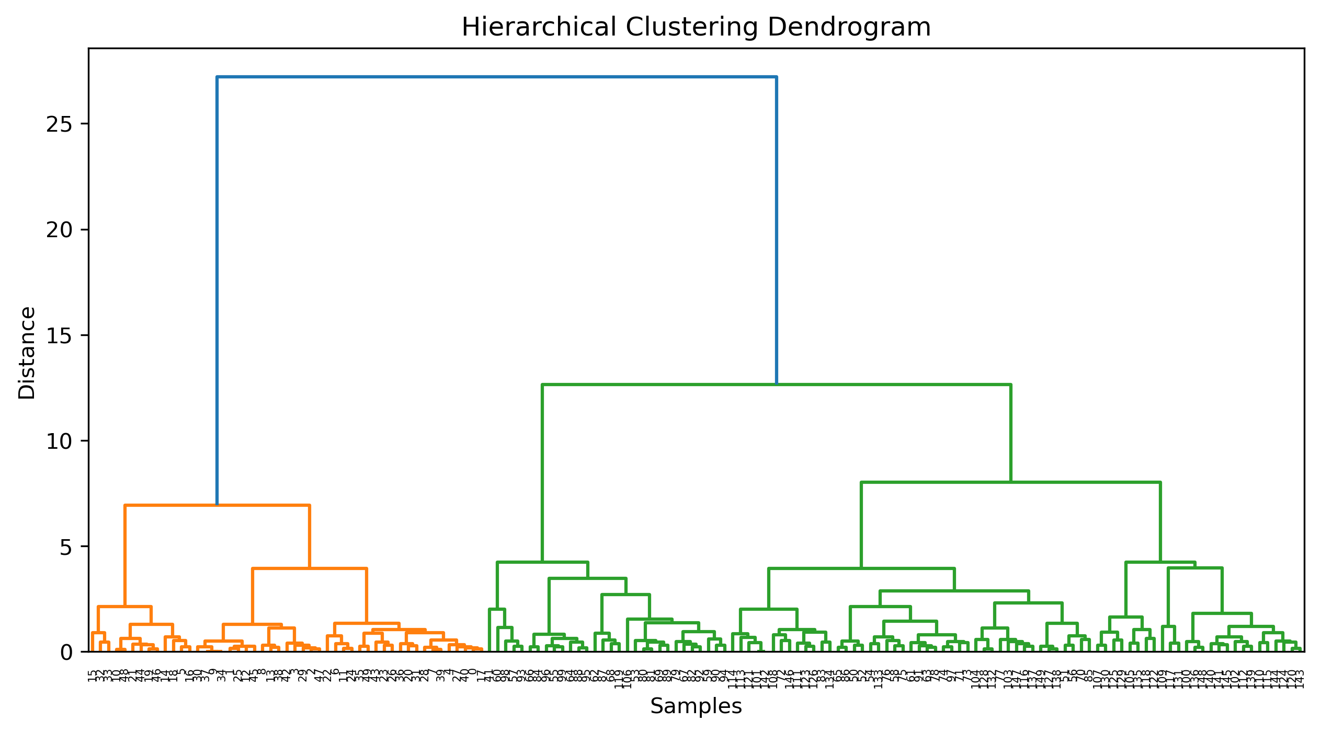
Experiment 3: Visual Comparison of Clusters
a) Visualization of Clusters side-by-side.
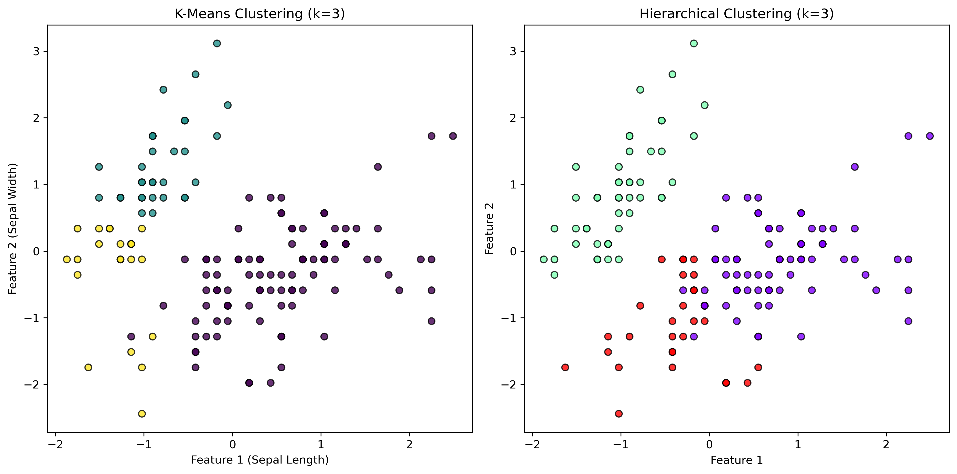
------------------------------------------------
Answers:
1. Why is scaling important for K-Means?
It ensures all features contribute equally to the distance calculation, preventing features with large scales from dominating.
2. How to choose optimal 'k'?
Commonly via the Elbow Method or using Silhouette Analysis to find the 'k' with the highest average silhouette score.
3. Difference between K-Means and Hierarchical?
K-Means partition based on centroids and requires 'k' upfront, while Hierarchical builds a nested tree (dendrogram).
4. Silhouette Score?
It measures cohesion (similarity in cluster) vs separation (difference from others). Higher is better.
5. When to use Hierarchical?
When you want to see the hierarchy of clusters or don't know 'k' and want to explore it visually.

